CIS 152 - Midterm/ Final Project

Donut Delights Client Website Description

Donut Delights

Tag Line: *The finest in breakfast treats and coffees since 1971*

Donut Delights has been serving C-U with the highest quality donuts and coffees since 1971. Nestled in downtown Urbana, Donut Delights has become a haven for “Gotta have it” breakfast treats. Our donuts are baked fresh twice daily and our coffee’s brewed every fifteen minutes. If you have never been to C-U’s hidden gem, you are missing out.

**Current Logo:**



**Image and Content Assets are on the Course GitHub repository, please include the following:**

Include store front photo

Interior shop and sampling of donut products

animated .gif provided

embedded youtube video provided

animated gallery available at: <http://www.menucool.com/javascript-image-slider>

**Navigation:** Home, About us, Contact, Location, Menu

I would like to have a simple background image that fits the theme

**Color palette:** I like the colors below but I am interested in seeing what you think works well.

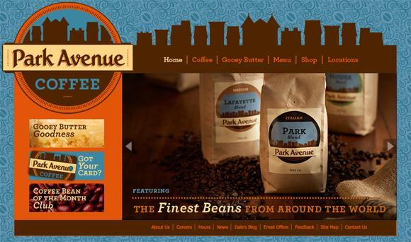



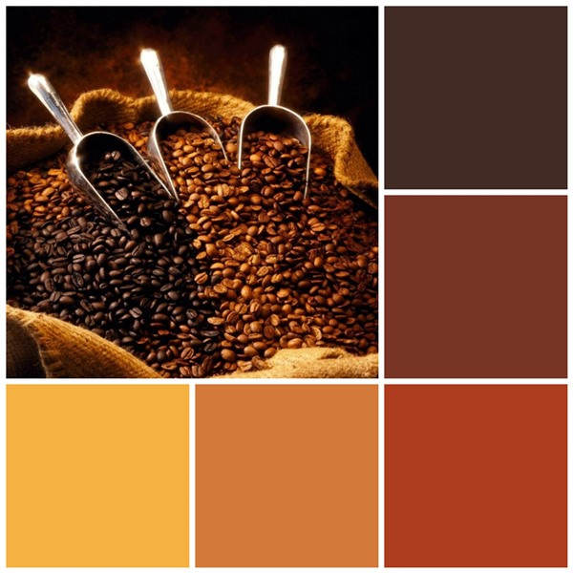

**About Us:** Donut Delights was started in 1971 by Melvin Furballski, an immigrant baker from the far east coast of Poland. Known far and wide for his delicate pastries, Melvin fled his homeland in search of a better life for his family. In 1970 he landed in New York City and by chance he found an open seat on a bus heading west. When an unexpected mechanical failure forced a three day delay in Champaign, Illinois, Furballski saw the need for a donut shop, so he decided to stay and make a new life for himself in Urbana, Illinois. With only one hundred dollars to his name, he found an abandoned breadshop and within two days he had one of a kind donuts flying off the racks faster than he could bake them and things have never slowed down. Now you can find that same great donut recipe plus dozens more still being made with the same love and care as when Donut Delights first opened.

A bakery fire in the mid-1980s destroyed many of the shop's records...but NOT THE RECIPES. While many people might have viewed the fire as an excuse to quit, Melvin instead used it as an opportunity to reconfigure the interior design, allowing him to add the coffee roastery section as well. So when you visit, be prepared for the inviting mix of aromas from fresh-roasted coffee beans and fresh-baked donuts: It's the closest thing to "Breakfast Heaven" anywhere in the C-U area!

**Menu:**

|  |  |  |  |
| --- | --- | --- | --- |
| **Bakers Dozen Donuts** regular donuts: chocolate frosted, vanilla frosted, boston cream, jelly filled, cream filled, glazed, chocolate glazed, marble twist, sugar raised, plain donut, plain cruller, honey wheat, jelly puff, cream puff, coffee roll. |  |  | (13) 8.65 |
| **Regular Donut** regular donuts: chocolate frosted, vanilla frosted, boston cream, jelly filled, cream filled, glazed, chocolate glazed, marble twist, sugar raised, plain donut, plain cruller, honey wheat, jelly puff, cream puff, coffee roll. |  |  | 1.05 |
| **Fancy Donut** fancy donuts: bow tie, éclair, apple turnover, fancy coffee roll. |  |  | 2.00 |
| **French Cruller** |  |  | 2.00 |

Top sellers:

Pistachio Pinwheels

Boston Cream delights

Chocolate confetti

Marshmallow Mayhems

French twists

Bulls Horns

Melvin would like a form to add customers emails to his coupon and special daily delights along with a comments section about their experience at the shop.

**Contact Info:**

Donut Delights

2112 Main Street Urbana , Illinois 61801

Insert a google map for location.

(217)-555- 1234

email: contact@donutdelights.com

**Additional must haves:**

* A Form for getting customer email for online promotions and special events. Use this copy for the page: *“Subscribe to our newsletter for the latest on our seasonal offerings and special events:”*
* Social Media Links: Facebook, Google+, Instagram, twitter
* Fun donut and coffee facts, jokes, useful or interesting info used to add humor and fun to site or famous artwork that features donuts or coffee as filler or added to gallery

**Example websites Mr. Furballski likes:**

1. <http://www.timhortons.com/us/en/index.php>
2. <http://www.littledogcoffeeshop.com/>
3. <http://roostercoffeehouse.com/hours-and-location>
4. <http://www.happygoatcoffee.com/>
5. <http://www.smashingmagazine.com/2010/08/10/showcase-of-delicious-coffee-websites/>
6. <http://www.kickinghorsecoffee.com/en/home>
7. <http://www.thebestcoffee.com/local/jones-coffee-roasters/>
8. <http://www.1369coffeehouse.com/>
9. <http://www.themugg.com/index.php>